1.

2.Select: Continuing Genealogical Education:
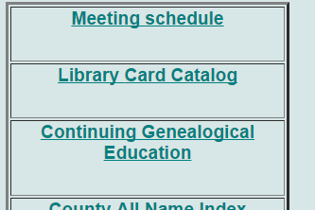

3.Select: 27 Africian American Genealogy
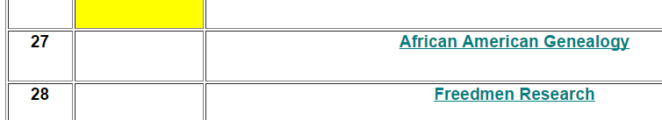
4. Select: 2016 Presentation....
